**Expt 4**

**/* TE CMPN A – 27 */**

**Server:-**

import java.io.*;

import java.net.*;

public class Sok_Server

{

public static void main(String args[]) throws Exception

{

Sok_Server serv = new Sok_Server();

serv.run();

}

public void run() throws Exception

{

ServerSocket servsock = new ServerSocket(9999);

Socket sock=servsock.accept();

InputStreamReader ir = new InputStreamReader(sock.getInputStream());

BufferedReader br=new BufferedReader(ir);

String message=br.readLine();

System.out.print(message);

if(message!=null)

{

PrintStream ps = new PrintStream(sock.getOutputStream());

System.out.println();

ps.println("Welcome to Server.");

System.out.println();

}

}

}

**/*OUTPUT:**

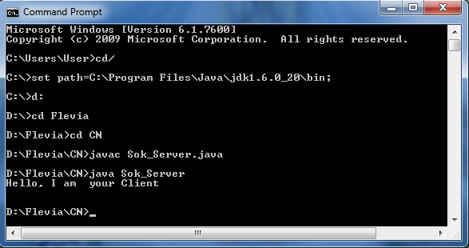**\*/**

**Client**

import java.io.*;

import java.net.*;

public class Sok_Client

{

public static void main(String args[]) throws Exception

{

Sok_Client clt = new Sok_Client();

clt.run();

}

public void run() throws Exception

{

Socket sock = new Socket("localhost",9999);

PrintStream ps = new PrintStream(sock.getOutputStream());

ps.println("Hello, I am your Client");

InputStreamReader ir = new InputStreamReader(sock.getInputStream());

BufferedReader br=new BufferedReader(ir);

String message=br.readLine();

System.out.print(message);

}

}

/\***OUTPUT: 